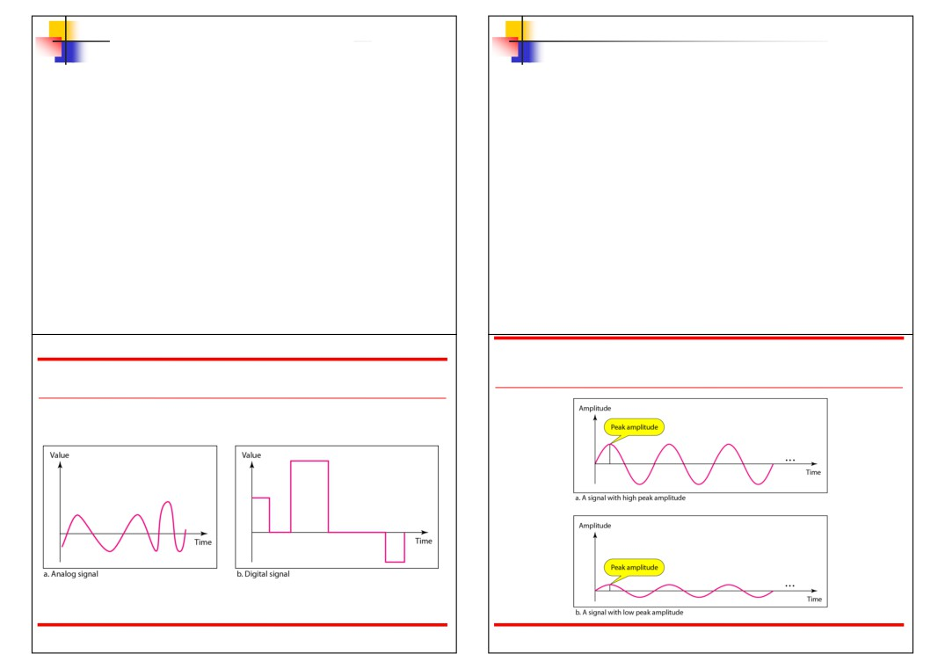

Analog and Digital Data

▪ Data can be analog or digital.   
▪ Analog data are continuous and take

continuous values.

▪ Digital data have discrete states and take   
 discrete values.

3.# 1

Analog and Digital Signals

• Signals can be analog or digital.

• Analog signals can have an infinite number

of values in a range.

• Digital signals can have only a limited   
 number of values.

3.# 2

Figure 3.3 Two signals with the same phase and frequency,

Figure 3.1 Comparison of analog and digital signals

3.# 3

but different amplitudes

3.# 4

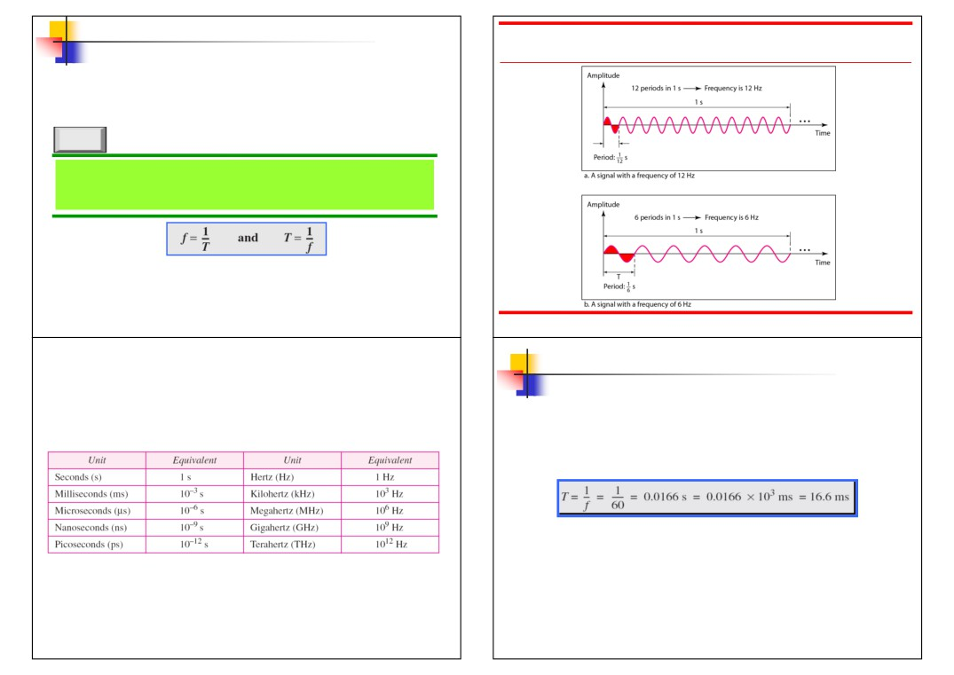

Figure 3.4 Two signals with the same amplitude and phase,   
 but different frequencies

Note

Frequency and period are the inverse of

each other.

3.# 5 3.# 6

Example 3.1

The power we use at home has a frequency of 60 Hz.

Table 3.1 Units of period and frequency

3.#

The period of this sine wave can be determined as

follows:

7 3.# 8

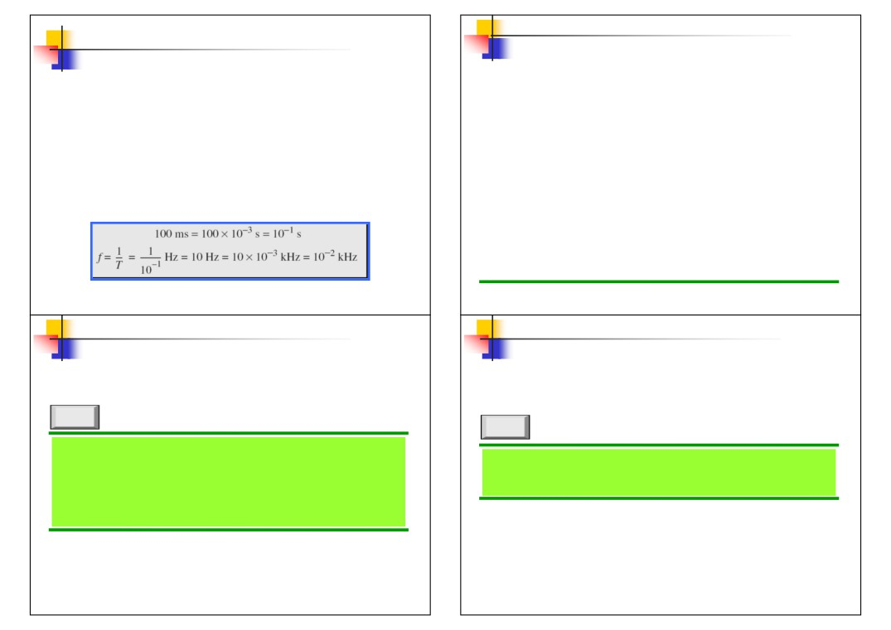

Example 3.2

Frequency

The period of a signal is 100 ms. What is its frequency

in kilohertz?

Solution

First we change 100 ms to seconds, and then we   
calculate the frequency from the period (1 Hz = 10−3   
kHz).

3.# 9

Note

If a signal does not change at all, its   
 frequency is zero.

If a signal changes instantaneously, its

frequency is infinite.

3.# 11

• Frequency is the rate of change with respect   
 to time.

• Change in a short span of time means high   
 frequency.

• Change over a long span of   
 time means low frequency.

3.# 10

Note

Phase describes the position of the

waveform relative to time 0.

3.# 12

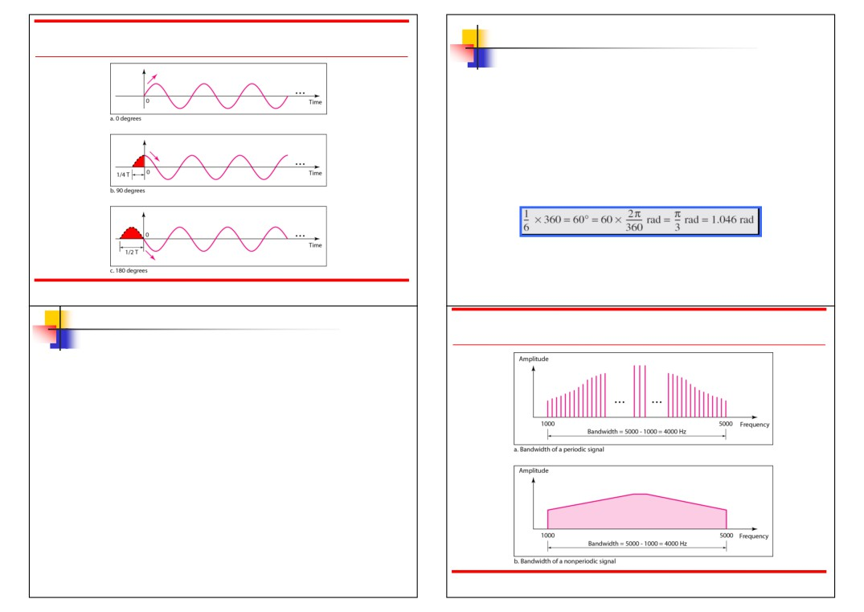

Figure 3.5 Three sine waves with the same amplitude and frequency,   
 but different phases

3.# 13

Bandwidth and Signal

Frequency

■ The bandwidth of a composite signal is   
 the difference between the highest and

the lowest frequencies contained in that signal.

3.# 15

Example 3.3

A sine wave is offset 1/6 cycle with respect to time 0.

What is its phase in degrees and radians?

Solution

We know that 1 complete cycle is 360°. Therefore, 1/6

cycle is

3.# 14

Figure 3.12 The bandwidth of periodic and nonperiodic composite signals

3.# 16

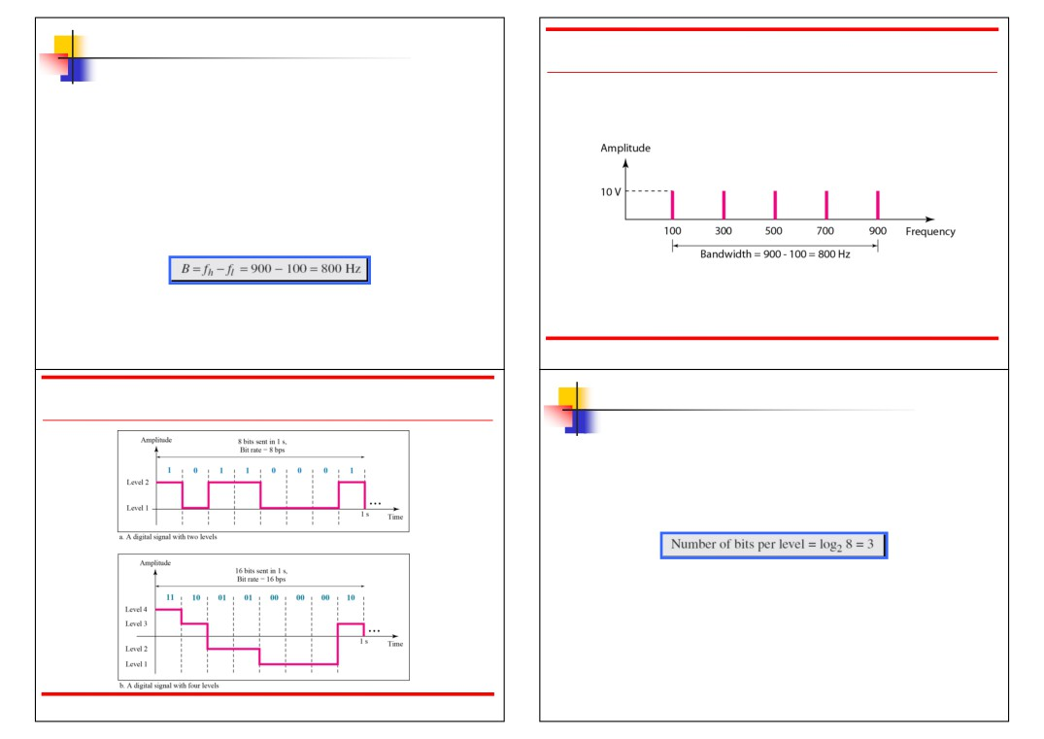

Example 3.6

If a periodic signal is decomposed into five sine   
waves with frequencies of 100, 300, 500, 700, and 900   
Hz, what is its bandwidth? Draw the spectrum,   
assuming all components have a maximum amplitude   
of 10 V.

Solution

Let fh be the highest frequency, fl the lowest frequency, and B the bandwidth. Then

The spectrum has only five spikes, at 100, 300, 500, 700, and 900 Hz (see Figure 3.13).

Figure 3.13 The bandwidth for Example 3.6

3.# 17 3.# 18

Figure 3.16 Two digital signals: one with two signal levels and the other Example 3.16

with four signal levels

A digital signal has eight levels. How many bits are   
needed per level? We calculate the number of bits

from the formula

Each signal level is represented by 3 bits.

3.# 19 3.# 20

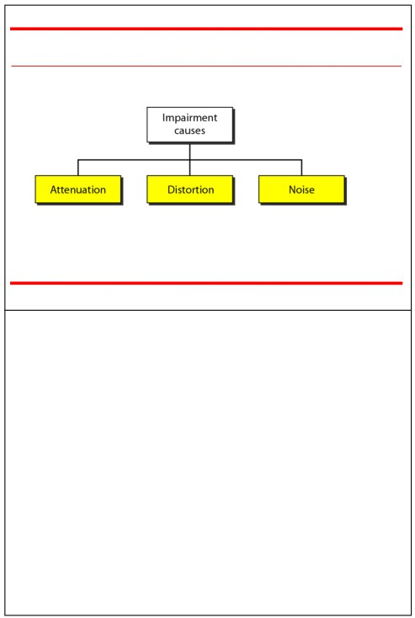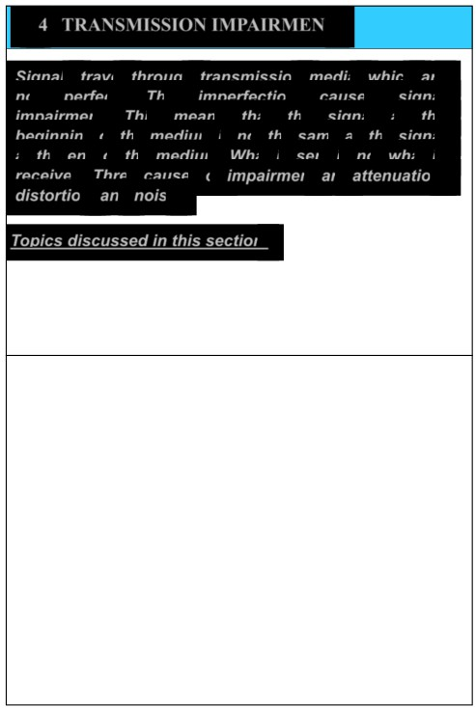

3-4 TRANSMISSION IMPAIRMENT

Figure 3.25 Causes of impairment

Signals travel through transmission media, which are

not perfect. The imperfection causes signal

impairment. This means that the signal at the beginning of the medium is not the same as the signal at the end of the medium. What is sent is not what is received. Three causes of impairment are attenuation, distortion, and noise.

Topics discussed in this section:

Attenuation

▪ Distortion   
▪ Noise

3.# 21 3.# 22

Attenuation

■ Means loss of energy -> weaker signal   
■ When a signal travels through a medium it

loses energy overcoming the resistance of

Measurement of Attenuation

■ To show the loss or gain of energy the unit   
 “decibel” is used.

the medium

■ Amplifiers are used to compensate for this   
 loss of energy by amplifying the signal.

3.#

dB = 10log10P2/P   
 P1 - input signal   
P2 - output signal

23 3.#

1

24

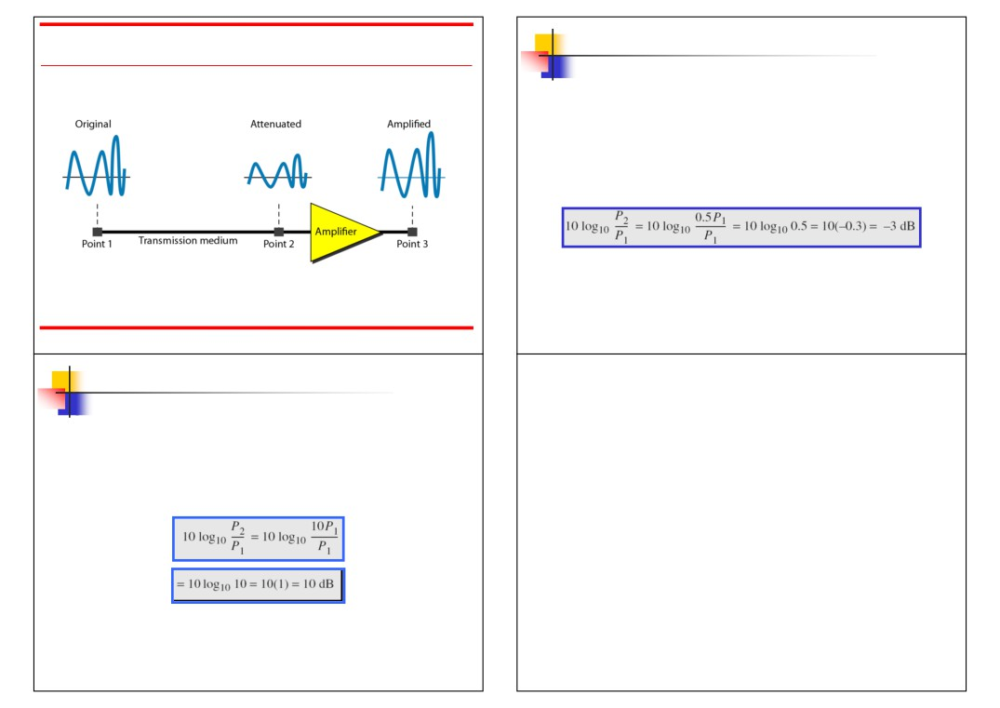

Figure 3.26 Attenuation

3.# 25

Example 3.26

Suppose a signal travels through a transmission

medium and its power is reduced to one-half. This means that P2 is (1/2)P1. In this case, the attenuation (loss of power) can be calculated as

A loss of 3 dB (-3 dB) is equivalent to losing one-half the power.

3.# 26

Example 3.27

Distortion

A signal travels through an amplifier, and its power is increased 10 times. This means that P2 = 10P1 . In this case, the amplification (gain of power) can be calculated as

3.# 27

■ Means that the signal changes its form or shape  Distortion occurs in composite signals

■ Each frequency component has its own

propagation speed traveling through a medium.   
■ The different components therefore arrive with

different delays at the receiver.

■ That means that the signals have different phases   
 at the receiver than they did at the source.

3.# 28

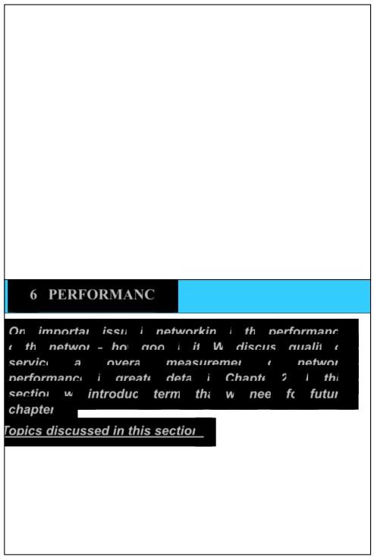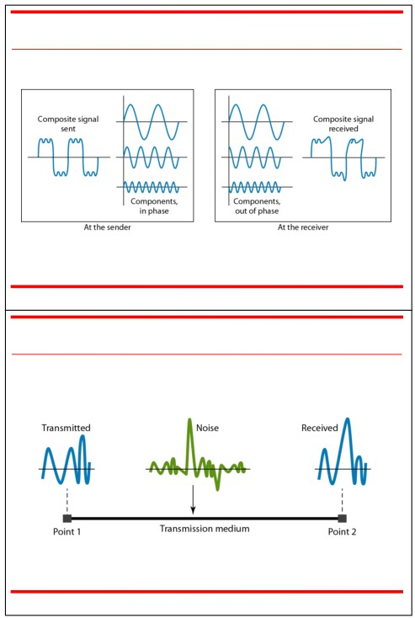

Figure 3.28 Distortion

Noise

■ There are different types of noise

■ Thermal - random noise of electrons in the wire creates an extra signal

■ Induced - from motors and appliances, devices act are transmitter antenna and medium as receiving antenna.

■ Crosstalk - same as above but between two   
wires.

■ Impulse - Spikes that result from power lines, lighning, etc.

3.# 29 3.# 30

Figure 3.29 Noise

3.# 31

3-6 PERFORMANCE

One important issue in networking is the performance   
of the network—how good is it? We discuss quality of

service, an overall measurement of network   
performance, in greater detail in Chapter 24. In this

section, we introduce terms that we need for future

chapters.

Topics discussed in this section:

▪ Bandwidth - capacity of the system ▪ Throughput - no. of bits that can be pushed through

▪ Latency (Delay) - delay incurred by a bit from start to finish

▪ Bandwidth-Delay Product 3.# 32

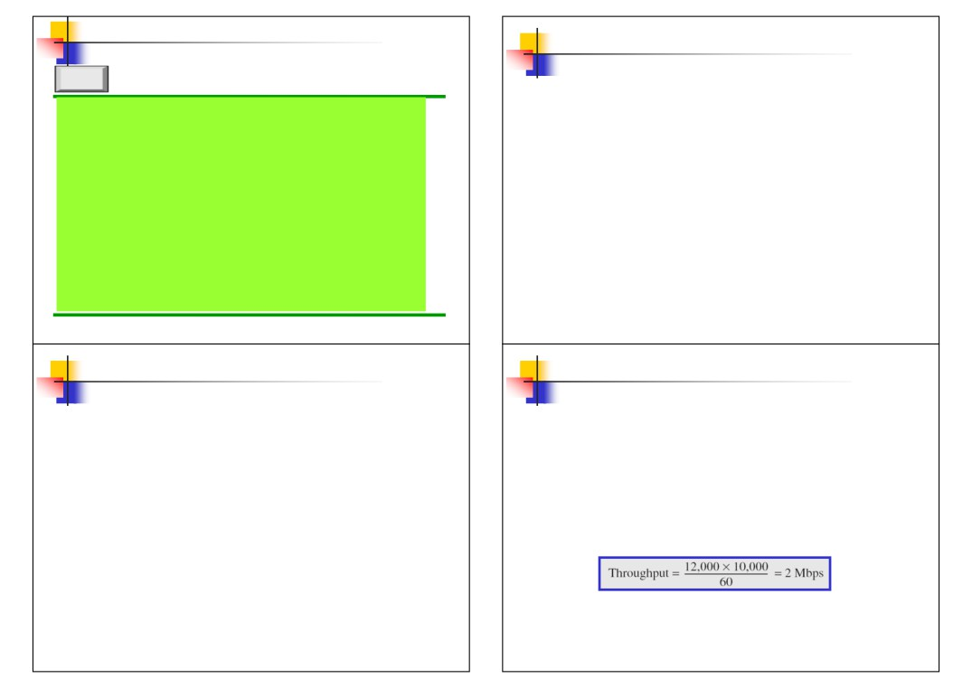

Example 3.42

Note

The bandwidth of a subscriber line is 4 kHz for voice

In networking, we use the term bandwidth   
 in two contexts.

▪ The first, bandwidth in hertz, refers to the range of frequencies in a composite signal or the range of frequencies that a channel can pass.

▪ The second, bandwidth in bits per second, refers to the speed of bit transmission in a channel or link. Often referred to as Capacity.

3.# 33

Example 3.43

If the telephone company improves the quality of the line and increases the bandwidth to 8 kHz, we can send 112,000 bps by using the same technology as mentioned in Example 3.42.

3.# 35

or data. The bandwidth of this line for data

transmission

can be up to 56,000 bps using a sophisticated modem

to change the digital signal to analog.

3.# 34

Example 3.44

A network with bandwidth of 10 Mbps can pass only an average of 12,000 frames per minute with each frame carrying an average of 10,000 bits. What is the throughput of this network?

Solution

We can calculate the throughput as

The throughput is almost one-fifth of the bandwidth in

this case.

3.# 36

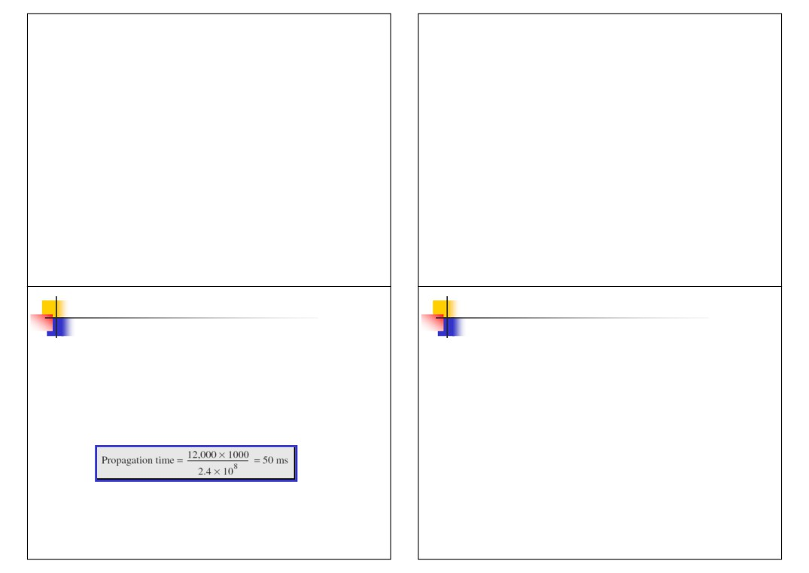

Propagation & Transmission delay

■ Propagation speed - speed at which a bit   
 travels though the medium from source to

destination.

■ Transmission speed - the speed at which all   
 the bits in a message arrive at the

destination. (difference in arrival time of first and last bit)

3.#

Propagation and Transmission Delay

■ Propagation Delay = Distance/Propagation speed

■ Transmission Delay = Message size/bandwidth bps

■ Latency = Propagation delay + Transmission delay +   
 Queueing time + Processing time

37 3.# 38

Example 3.45

What is the propagation time if the distance between the two points is 12,000 km? Assume the propagation speed to be 2.4 × 108 m/s in cable.

Solution

We can calculate the propagation time as

The example shows that a bit can go over the Atlantic

Ocean in only 50 ms if there is a direct cable between

the source and the destination.

3.# 39

Example 3.46

What are the propagation time and the transmission time for a 2.5-kbyte message (an e-mail) if the bandwidth of the network is 1 Gbps? Assume that the distance between the sender and the receiver is 12,000 km and that light travels at 2.4 × 108 m/s.

Solution

We can calculate the propagation and transmission

time as shown on the next slide:

3.# 40

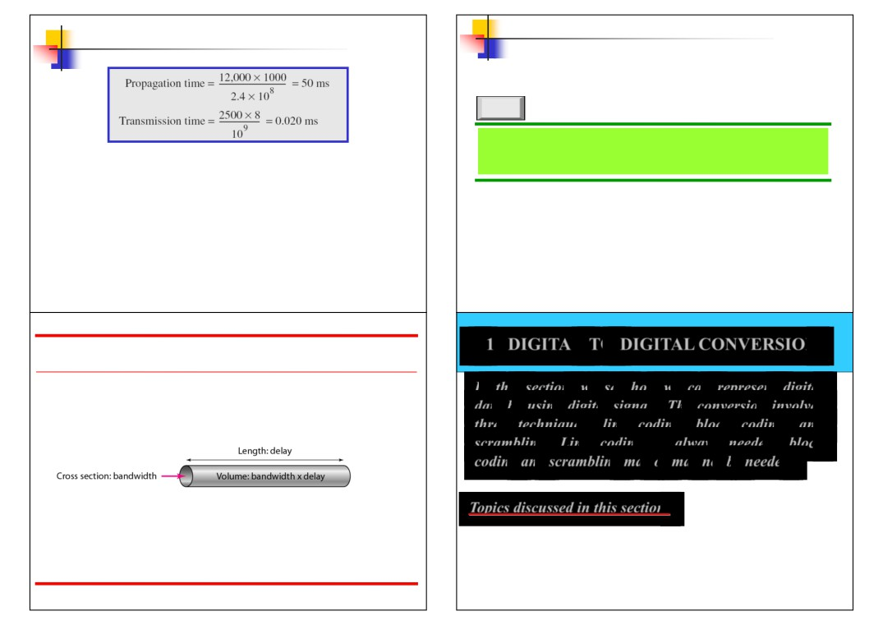

Example 3.46 (continued)

Note

The bandwidth-delay product defines the   
 number of bits that can fill the link.

Note that in this case, because the message is short   
and the bandwidth is high, the dominant factor is the

propagation time, not the transmission time. The

transmission time can be ignored.

3.# 41 3.# 42

4-1 DIGITAL-TO-DIGITAL CONVERSION

Figure 3.33 Concept of bandwidth-delay product

*In this section, we see how we can represent digital*

*data by using digital signals. The conversion involves*   
*three techniques: line coding, block coding, and*   
*scrambling. Line coding is always needed; block*   
*coding and scrambling may or may not be needed.*

*Topics discussed in this section:*

Line Coding Schemes

Block Coding

Scrambling

3.# 43

4.1

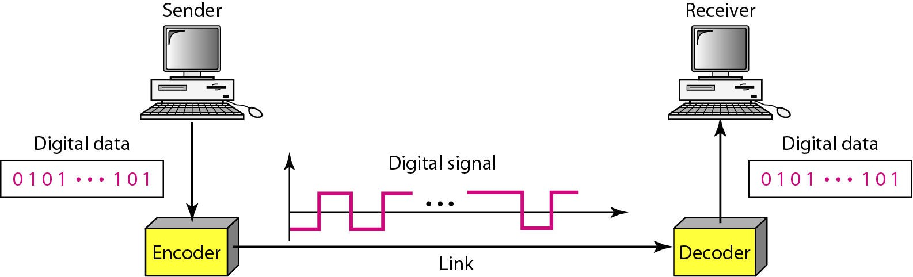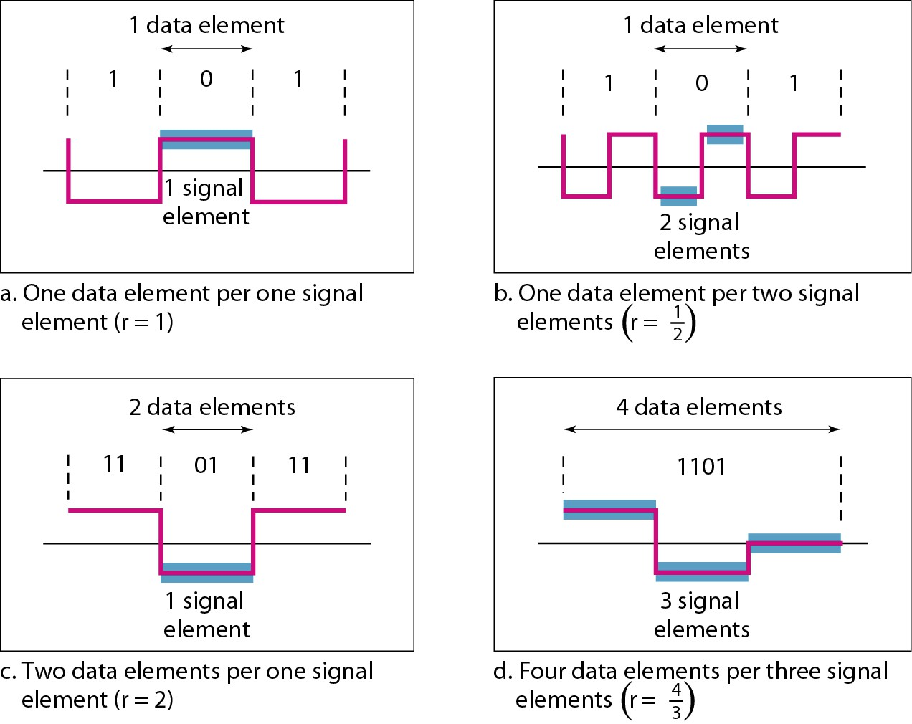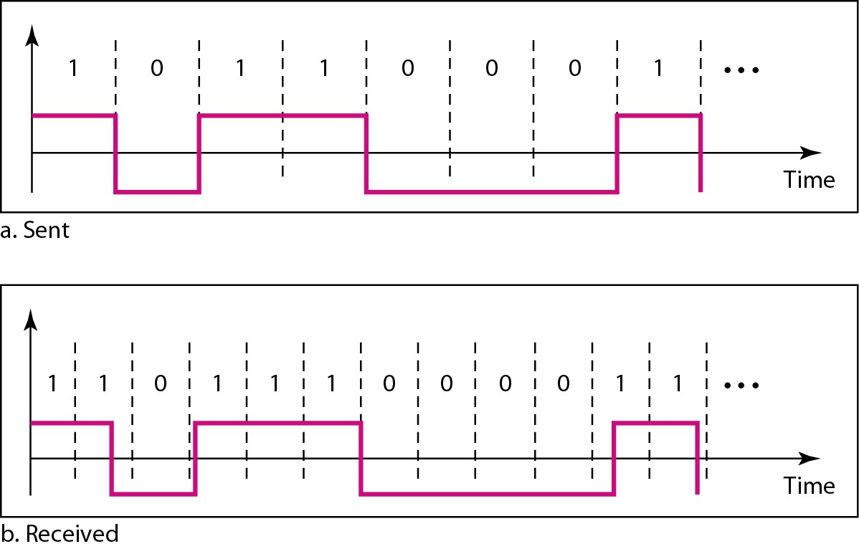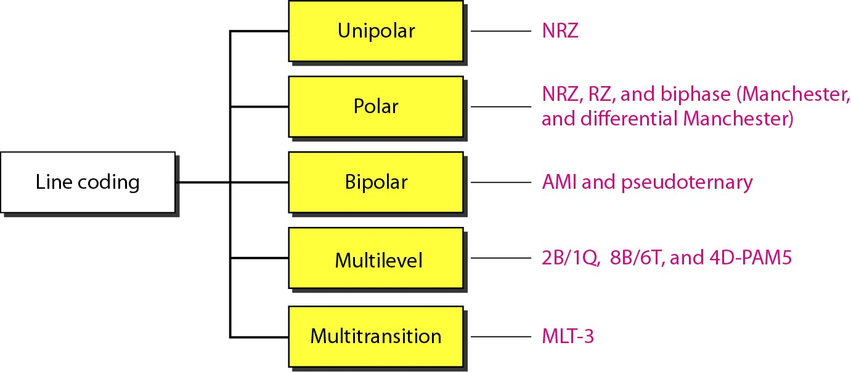

Figure 4.2 *Signal element versus data element*

Figure 4.1 *Line coding and decoding*

4.2 4.3

Figure 4.3 *Effect of lack of synchronization* Figure 4.4 *Line coding schemes*

4.4

4.5

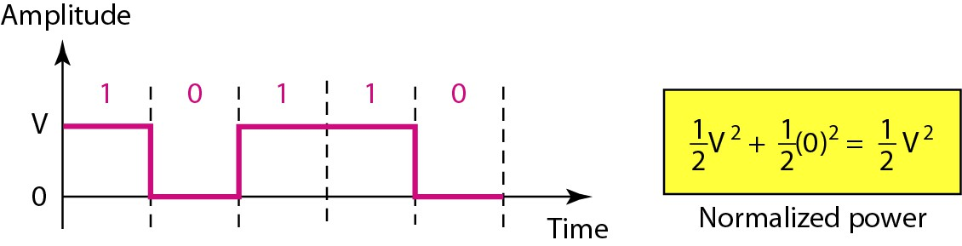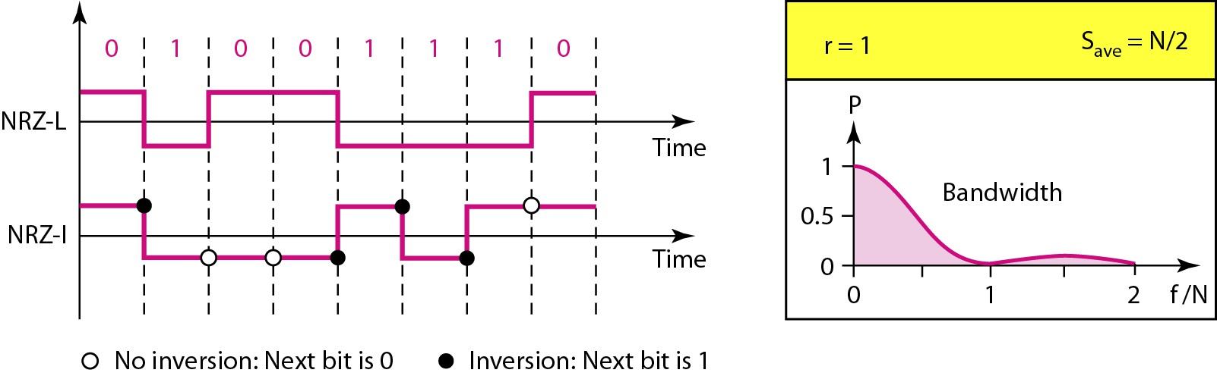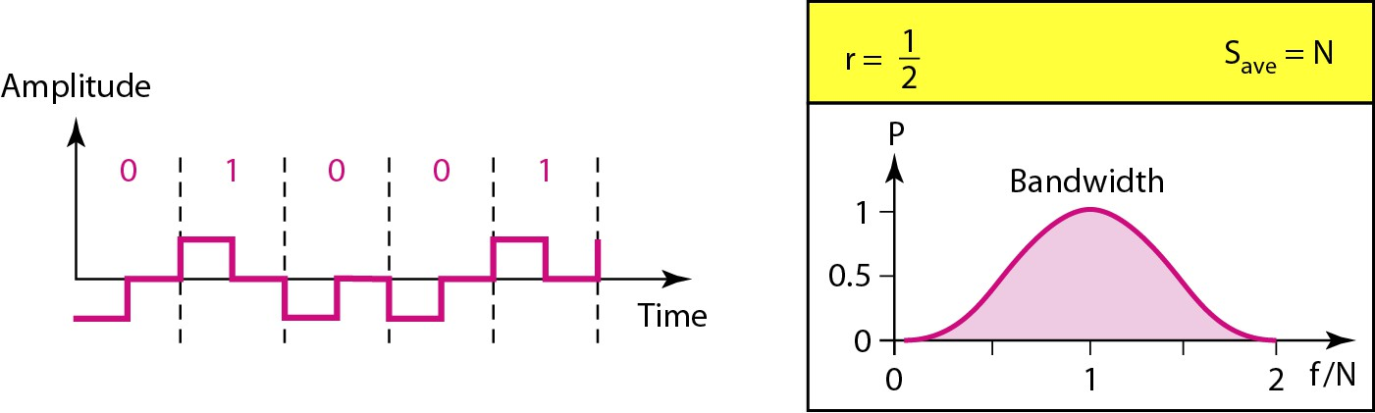

Figure 4.5 *Unipolar NRZ scheme* Figure 4.6 *Polar NRZ-L and NRZ-I schemes*

4.6 4.7

Figure 4.7 *Polar RZ scheme*

*Note*

In NRZ-L the level of the voltage determines the value of the bit.   
 In NRZ-I the inversion

or the lack of inversion

determines the value of the bit.

4.8

4.9

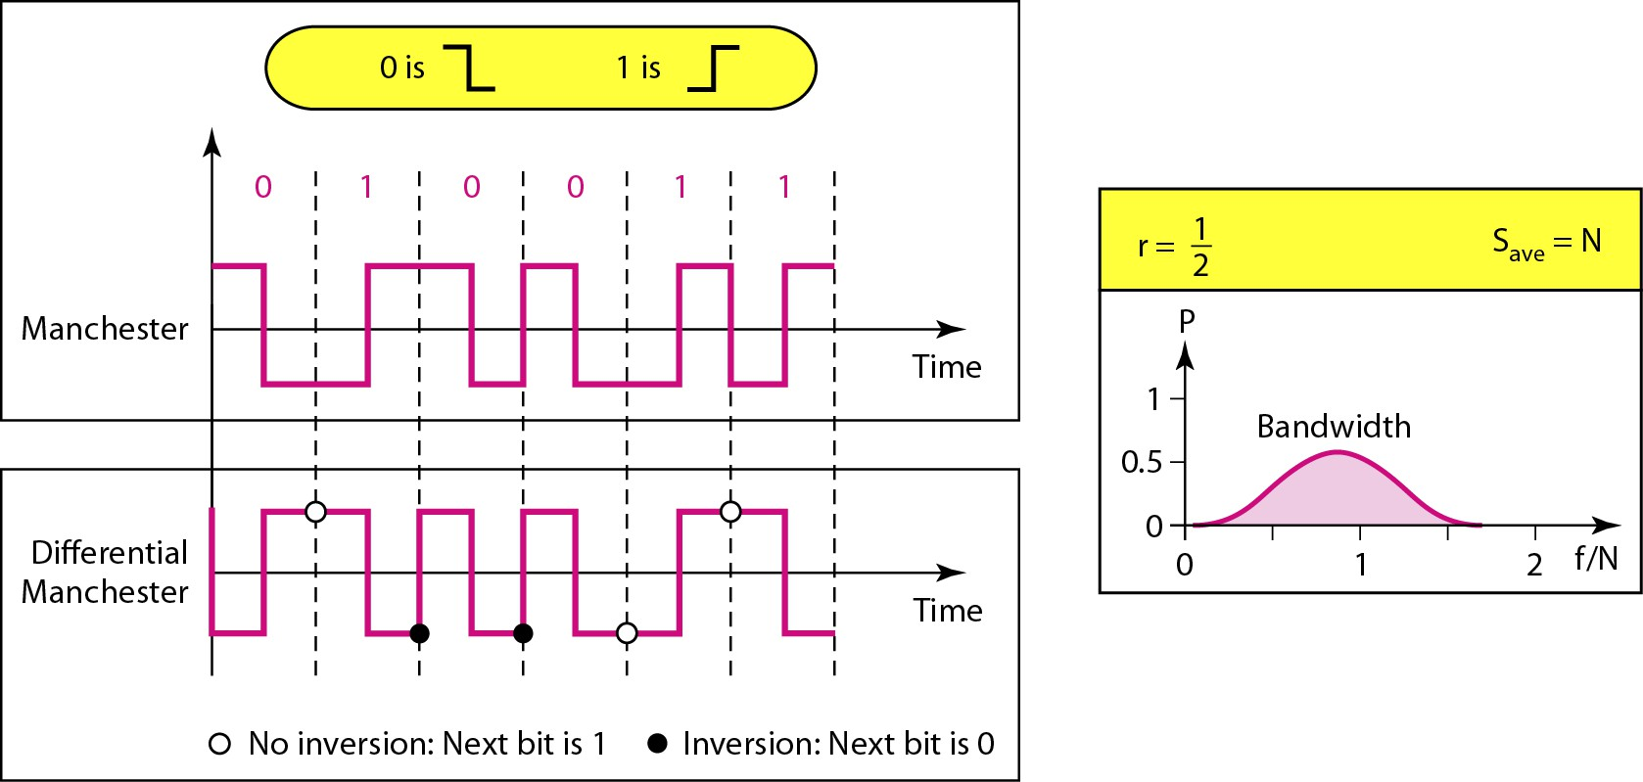

Figure 4.8 *Polar biphase: Manchester and differential Manchester schemes*

*Note*

In Manchester and differential

Manchester encoding, the transition   
at the middle of the bit is used for

synchronization.

4.10 4.11

*Note* *Note*

The minimum bandwidth of Manchester In bipolar encoding, we use three levels:

and differential Manchester is 2 times positive, zero, and negative.

that of NRZ.

4.12

4.13

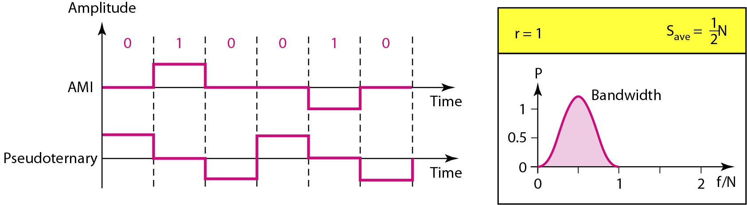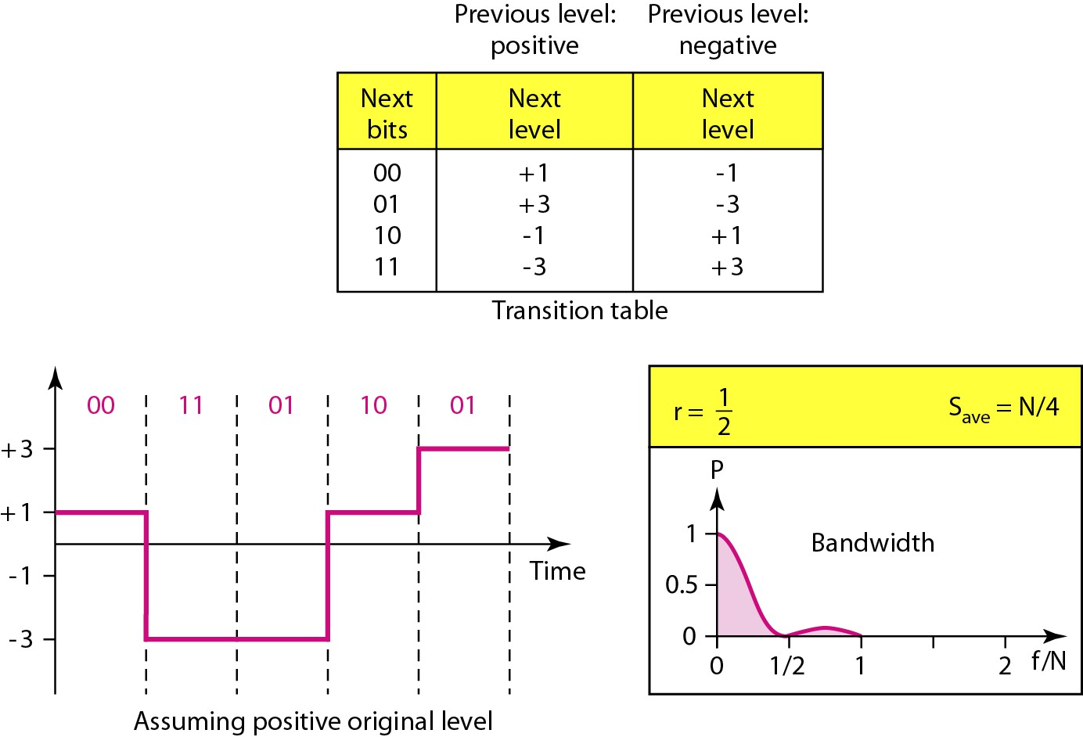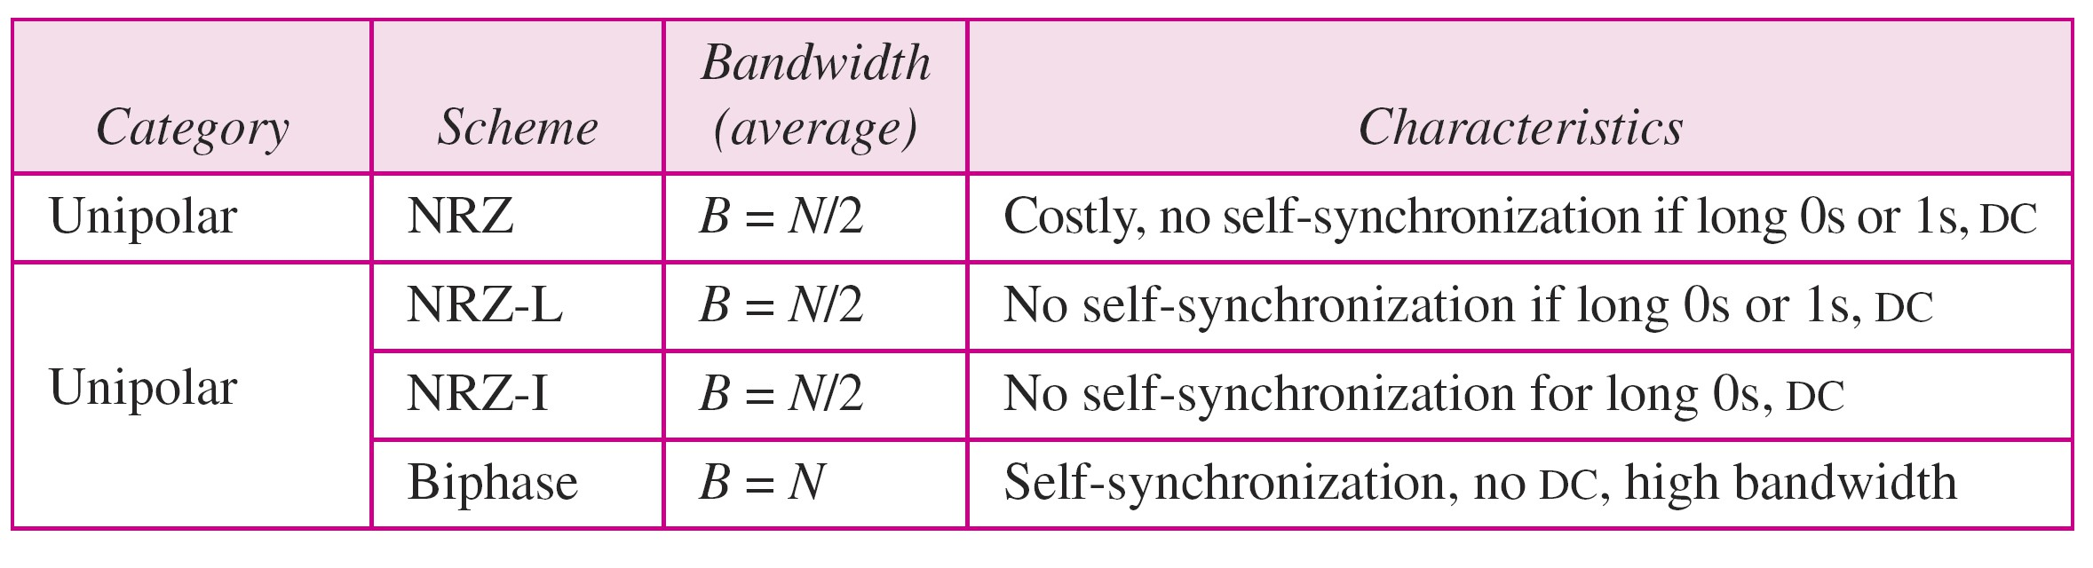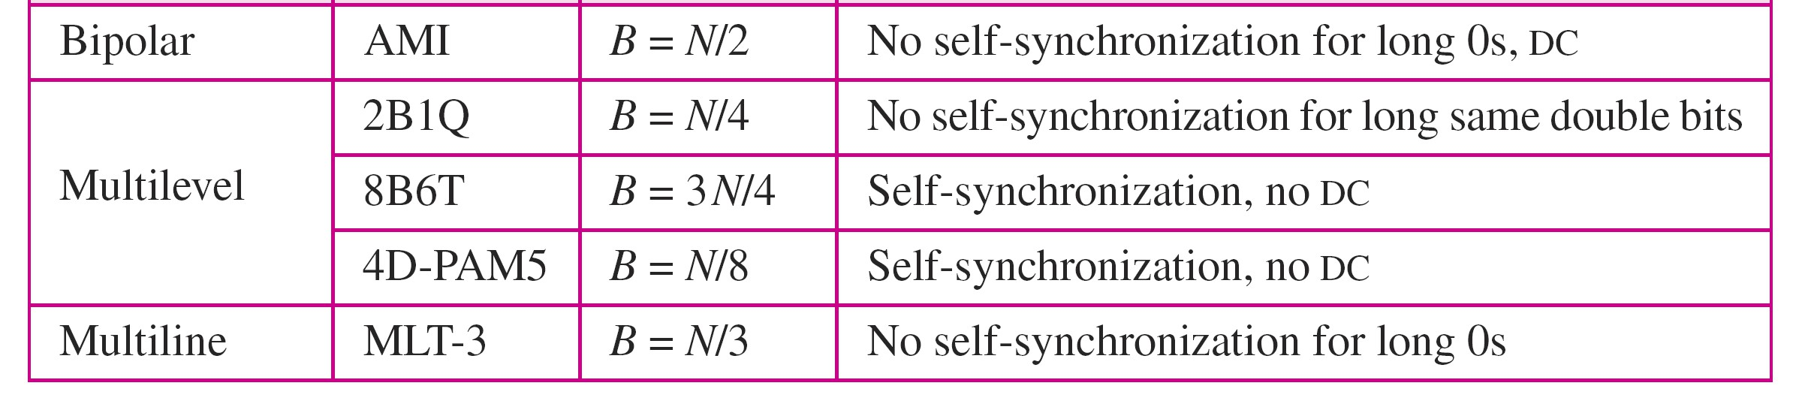

Figure 4.10 *Multilevel: 2B1Q scheme*

Figure 4.9 *Bipolar schemes: AMI and pseudoternary*

4.14 4.15

Table 4.1 *Summary of line coding schemes*

*Note*

Block coding is normally referred to as   
 mB/nB coding;

it replaces each m-bit group with an   
 n-bit group.

4.16

4.17

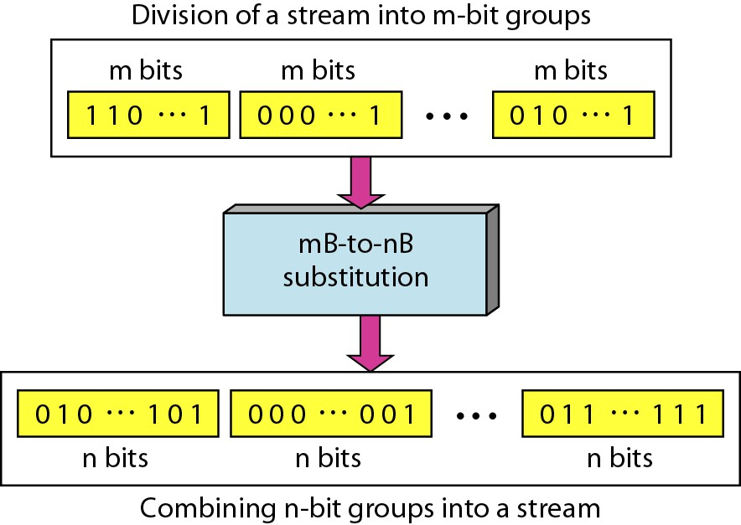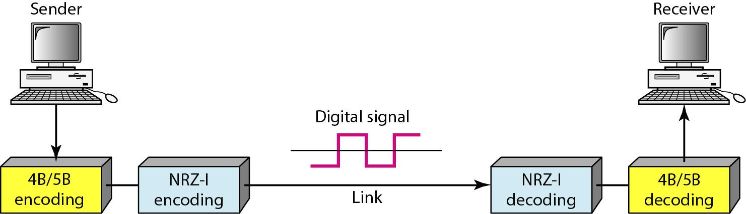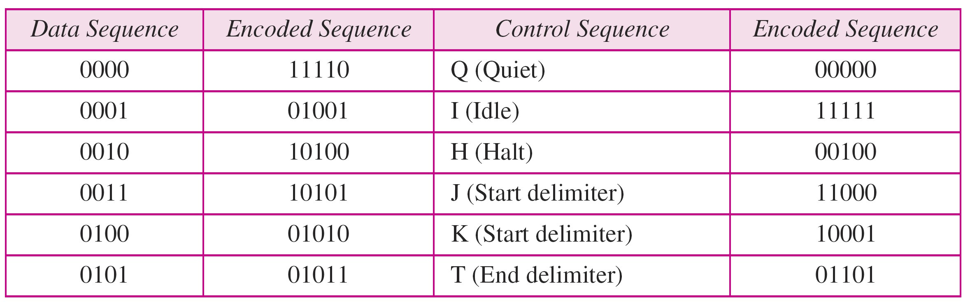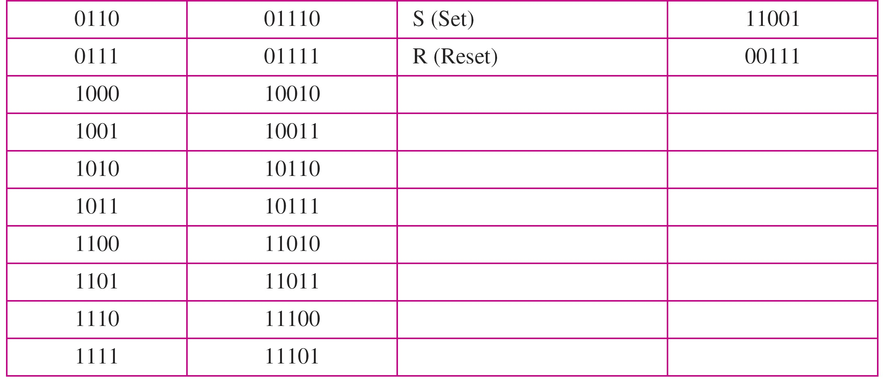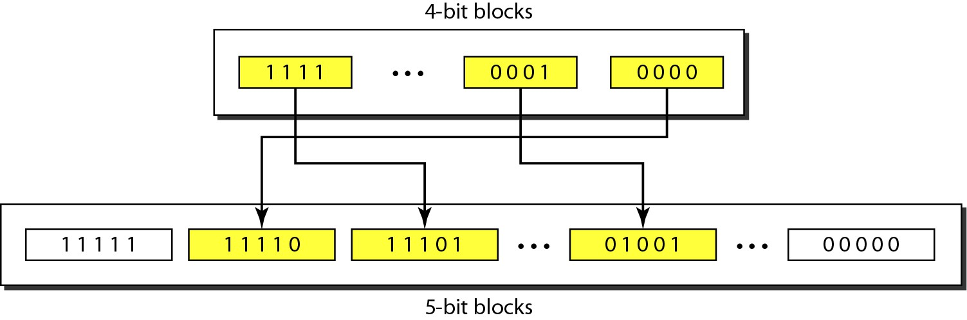

Figure 4.14 *Block coding concept*

Figure 4.15 *Using block coding 4B/5B with NRZ-I line coding scheme*

4.18 4.19

Table 4.2 *4B/5B mapping codes*

Figure 4.16 *Substitution in 4B/5B block coding*

4.20

4.21

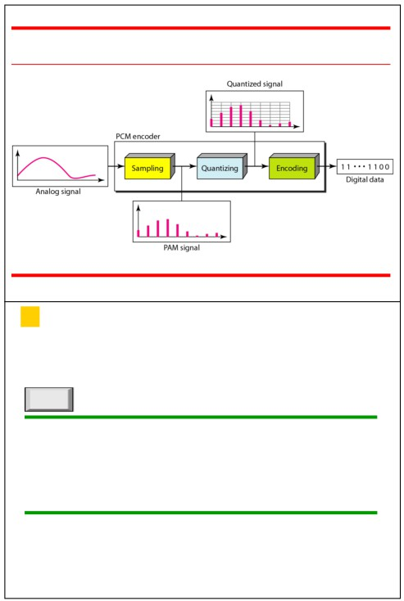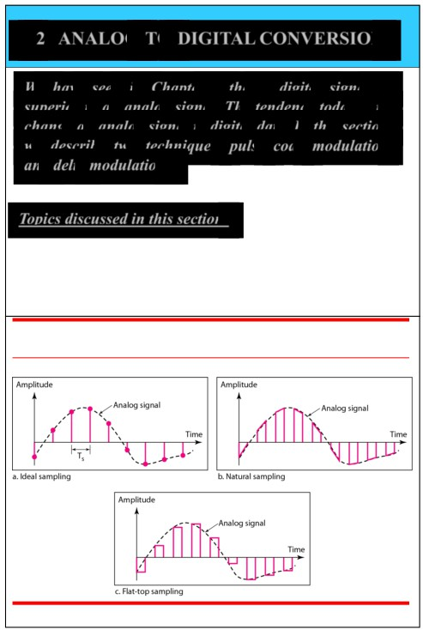

4-2 ANALOG-TO-DIGITAL CONVERSION

Figure 4.21 *Components of PCM encoder*

*We have seen in Chapter 3 that a digital signal is*   
*superior to an analog signal. The tendency today is to*

*change an analog signal to digital data. In this section we describe two techniques, pulse code modulation and delta modulation.*

*Topics discussed in this section:*

Delta Modulation (DM)

4.22 4.23

Figure 4.22 *Three different sampling methods for PCM*

*Note*

According to the Nyquist theorem, the   
 sampling rate must be

at least 2 times the highest frequency

contained in the signal.

4.24

4.25

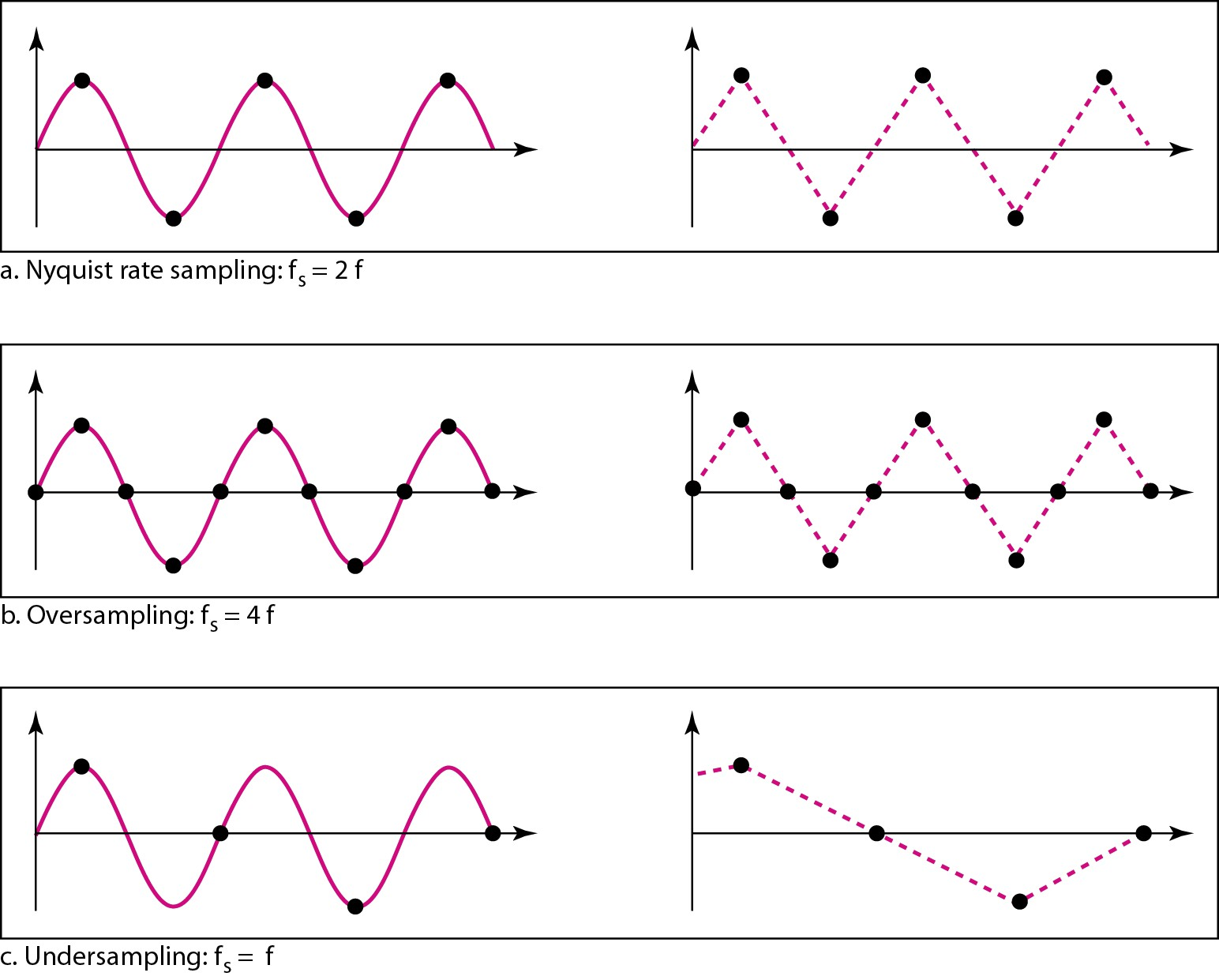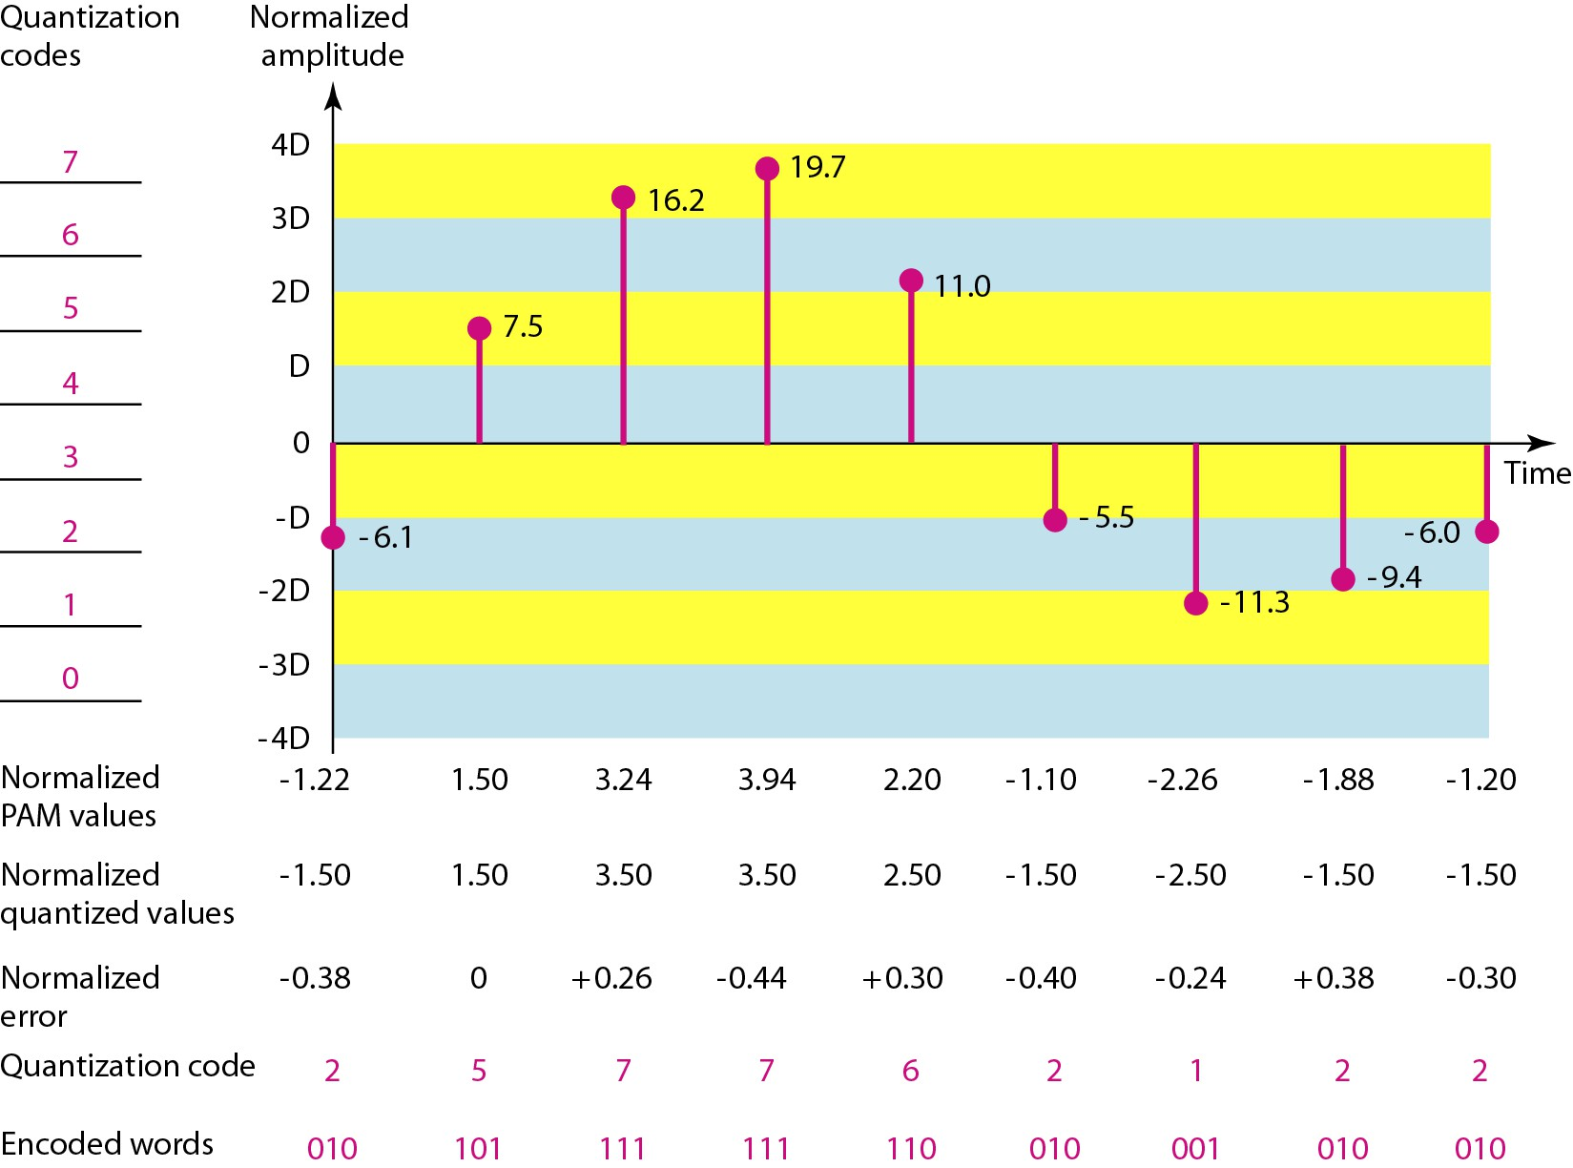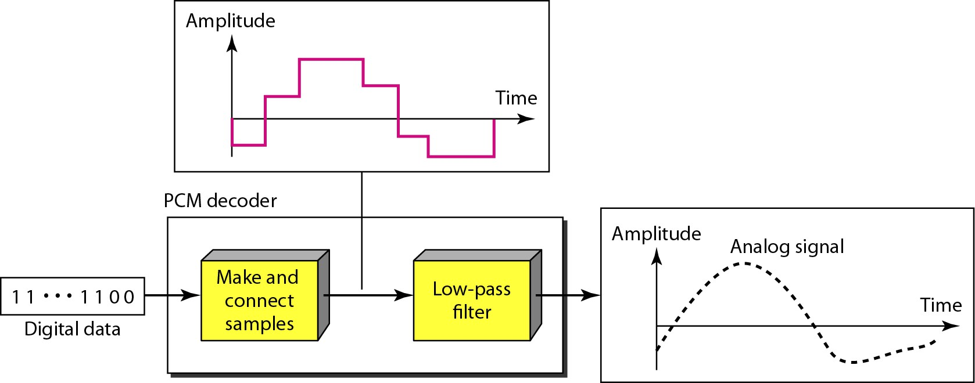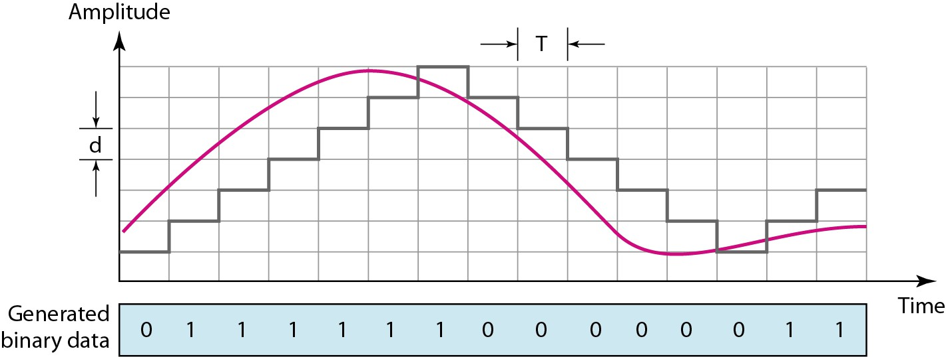

Figure 4.24 *Recovery of a sampled sine wave for different sampling rates* Figure 4.26 *Quantization and encoding of a sampled signal*

4.26 4.27

Figure 4.27 *Components of a PCM decoder*

Figure 4.28 *The process of delta modulation*

4.28

4.29

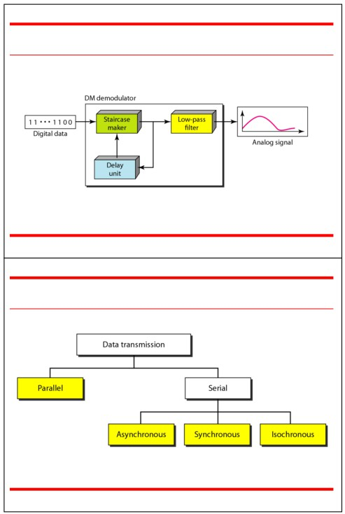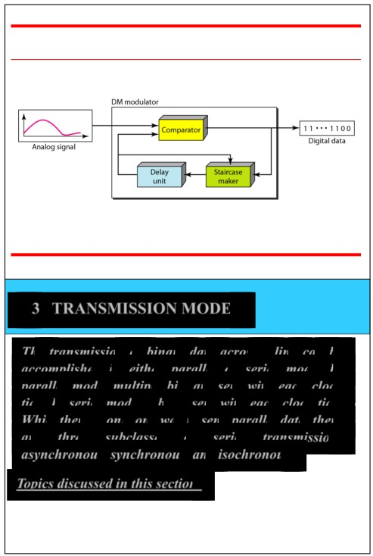

Figure 4.29 *Delta modulation components*

4.30

4-3 TRANSMISSION MODES

*The transmission of binary data across a link can be*   
*accomplished in either parallel or serial mode. In*   
*parallel mode, multiple bits are sent with each clock*   
*tick. In serial mode, 1 bit is sent with each clock tick.*   
*While there is only one way to send parallel data, there*

*are three subclasses of serial transmission:*

*asynchronous, synchronous, and isochronous. Topics discussed in this section:*

Serial Transmission

4.32

Figure 4.30 *Delta demodulation components*

4.31

Figure 4.31 *Data transmission and modes*

4.33

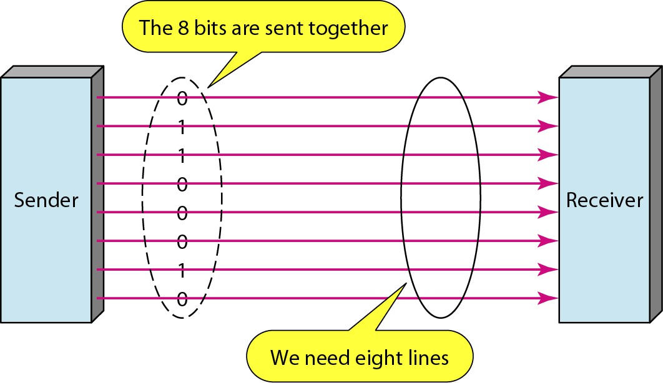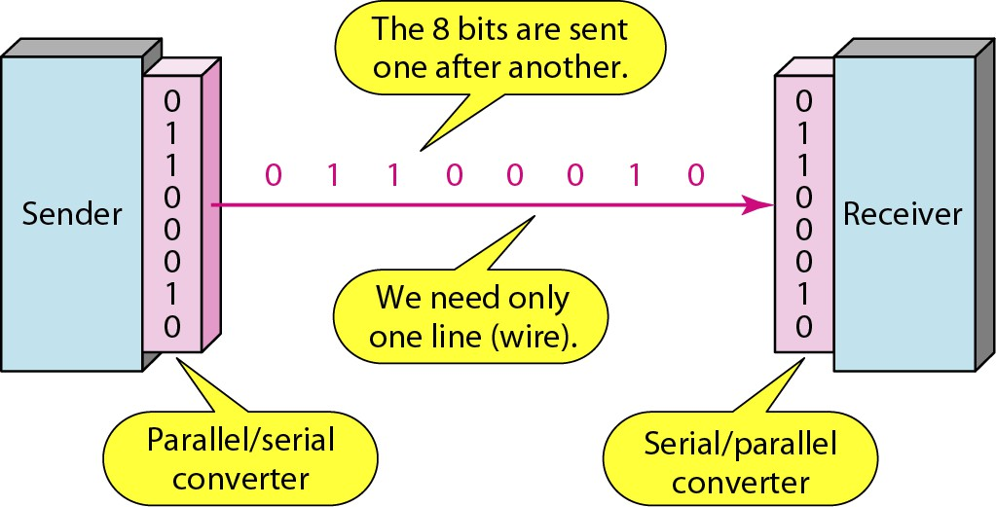

Figure 4.32 *Parallel transmission* Figure 4.33 *Serial transmission*

4.34 4.35

*Note* *Note*

In asynchronous transmission, we send Asynchronous here means

1 start bit (0) at the beginning and 1 or “asynchronous at the byte level,”

more stop bits (1s) at the end of each but the bits are still synchronized;

byte. There may be a gap between their durations are the same.

each byte.

4.36

4.37

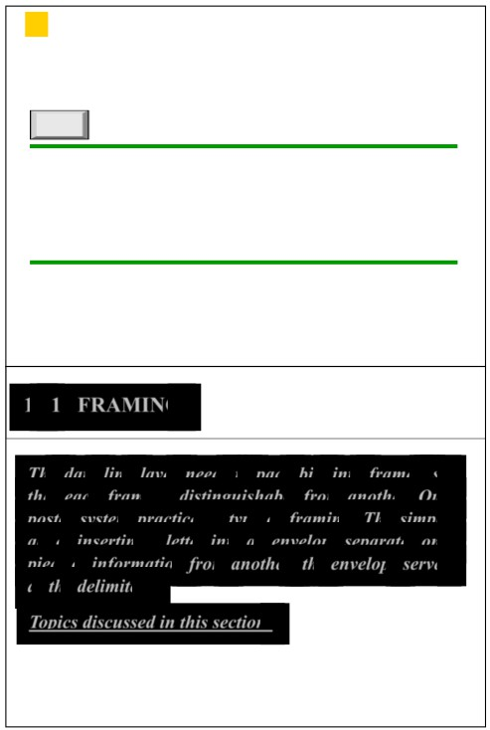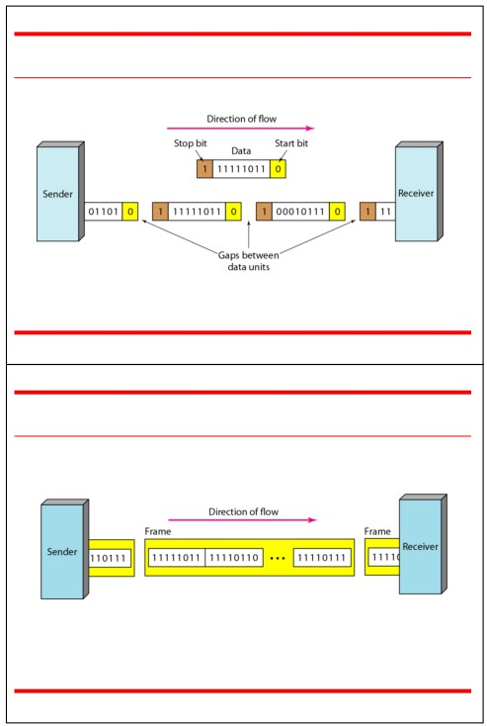

Figure 4.34 *Asynchronous transmission*

*Note*

In synchronous transmission, we send   
bits one after another without start or   
stop bits or gaps. It is the responsibility

of the receiver to group the bits.

4.38

Figure 4.35 *Synchronous transmission*

4.39

11-1 FRAMING

*The data link layer needs to pack bits into frames, so*   
*that each frame is distinguishable from another. Our*   
*postal system practices a type of framing. The simple*

*act of inserting a letter into an envelope separates one*

*piece of information from another; the envelope serves as the delimiter.*

*Topics discussed in this section:*

Variable-Size Framing

4.40

11.1

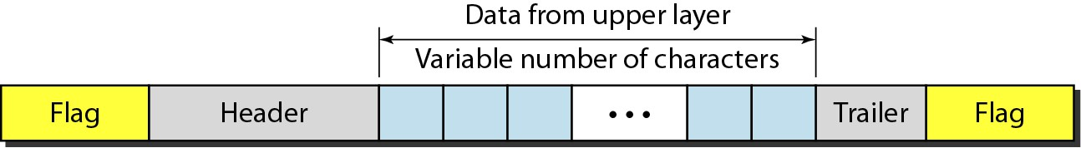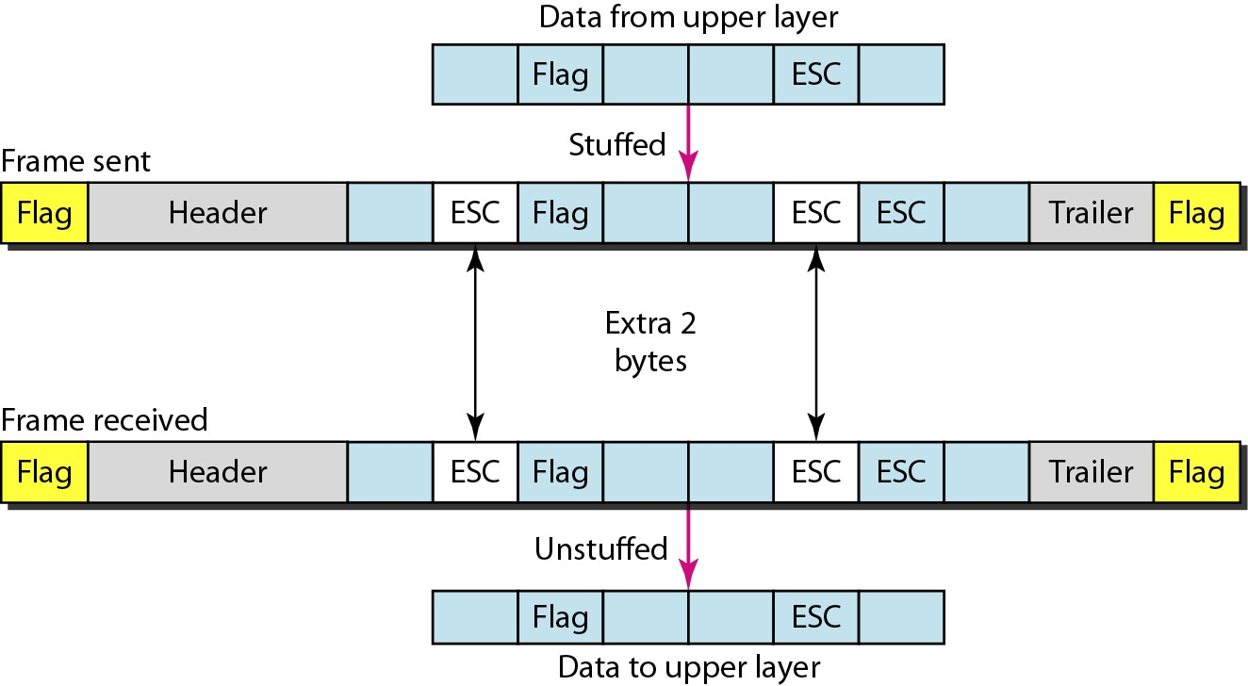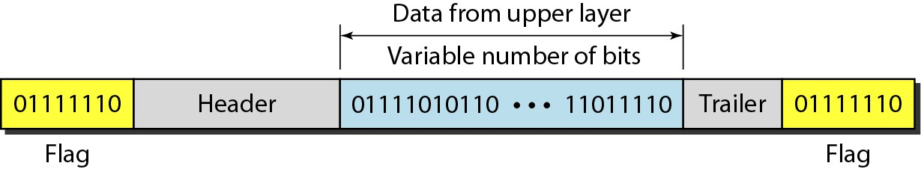

Figure 11.1 *A frame in a character-oriented protocol* Figure 11.2 *Byte stuffing and unstuffing*

11.2 11.3

Figure 11.3 *A frame in a bit-oriented protocol*

*Note*

Byte stuffing is the process of adding 1 extra byte whenever there is a flag or   
 escape character in the text.

11.4

11.5

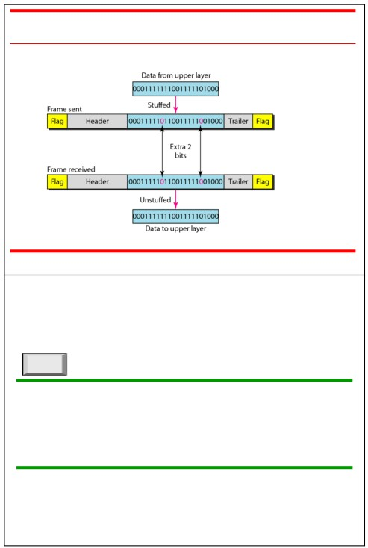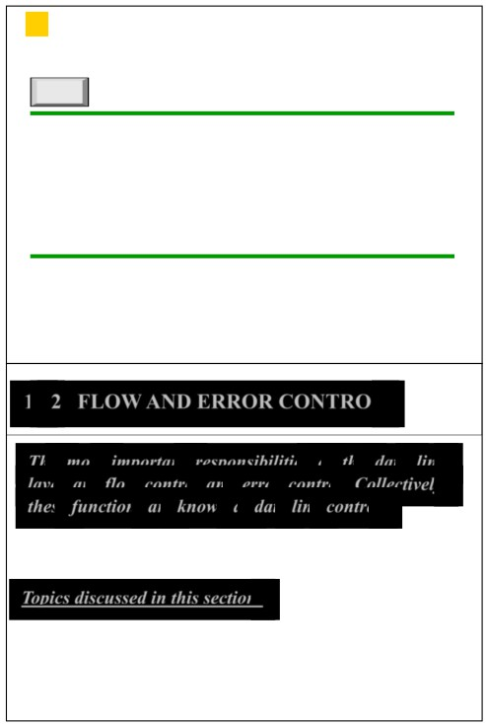

Figure 11.4 *Bit stuffing and unstuffing*

*Note*

Bit stuffing is the process of adding one extra 0 whenever five consecutive 1s

follow a 0 in the data, so that the

receiver does not mistake   
the pattern 0111110 for a flag.

11.6

11-2 FLOW AND ERROR CONTROL

*The most important responsibilities of the data link layer are flow control and error control. Collectively, these functions are known as data link control.*

*Topics discussed in this section:*

11.7

*Note*

Flow control refers to a set of procedures   
 used to restrict the amount of data

that the sender can send before

waiting for acknowledgment.

Error Control

11.8

11.9

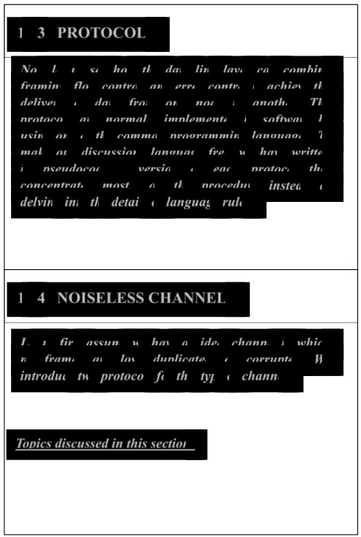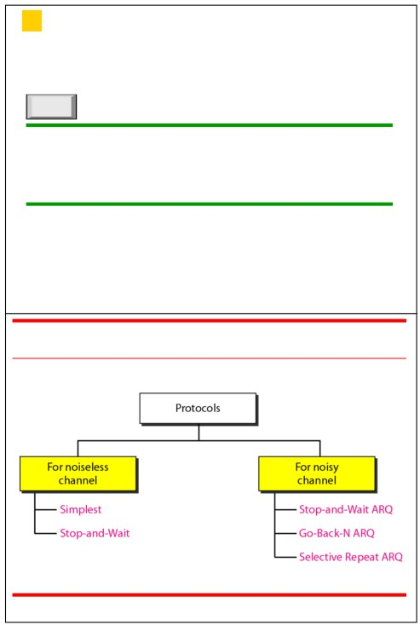

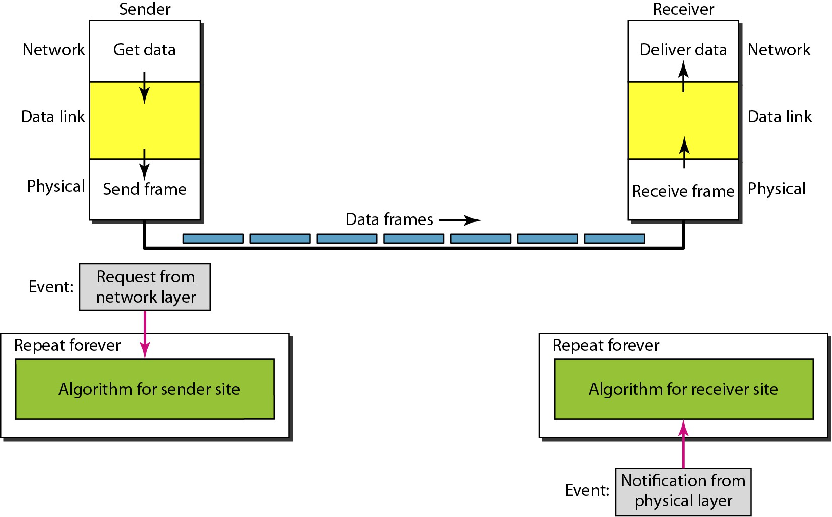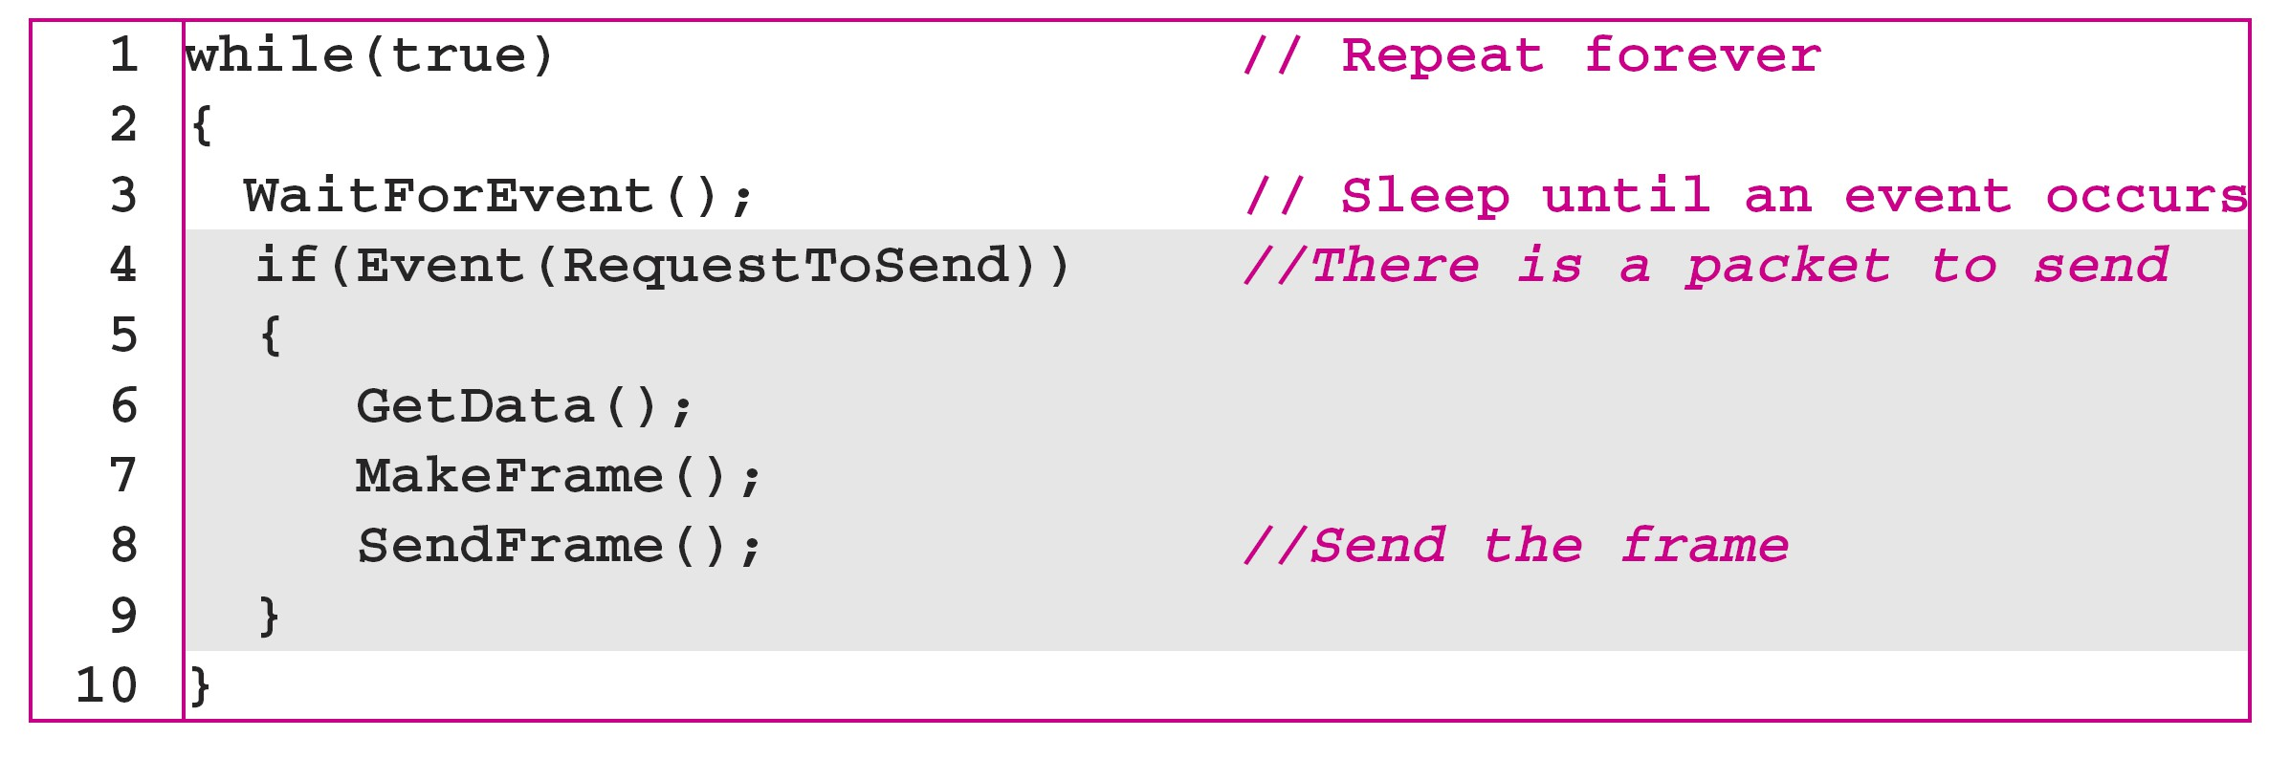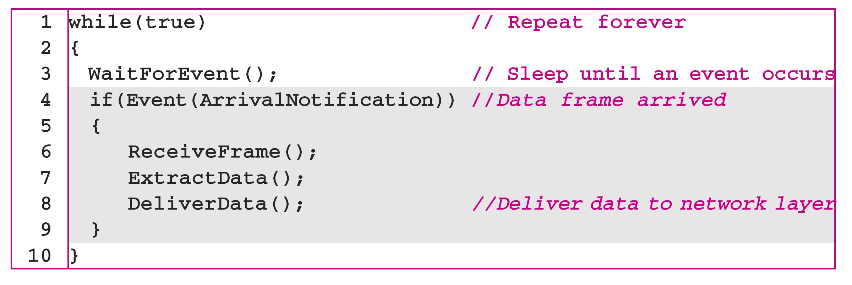

Figure 11.6 *The design of the simplest protocol with no flow or error control*

11.14

Algorithm 11.2 *Receiver-site algorithm for the simplest protocol*

11.16

Algorithm 11.1 *Sender-site algorithm for the simplest protocol*

11.15

*Example 11.1*

*Figure 11.7 shows an example of communication using this protocol. It is very simple. The sender sends a sequence of frames without even thinking about the receiver. To send three frames, three events occur at the sender site and three events at the receiver site. Note that the data frames are shown by tilted boxes; the height of the box defines the transmission time difference between the first bit and the last bit in the frame.*

11.17

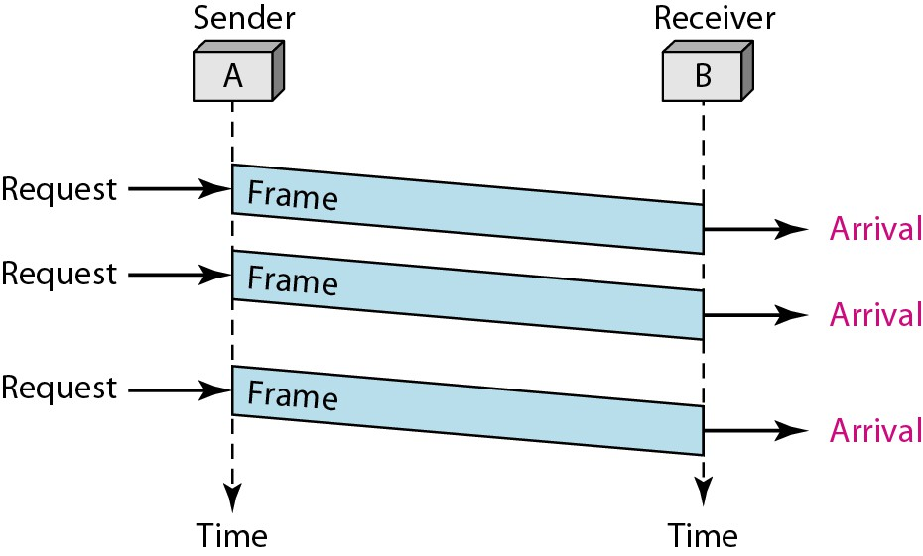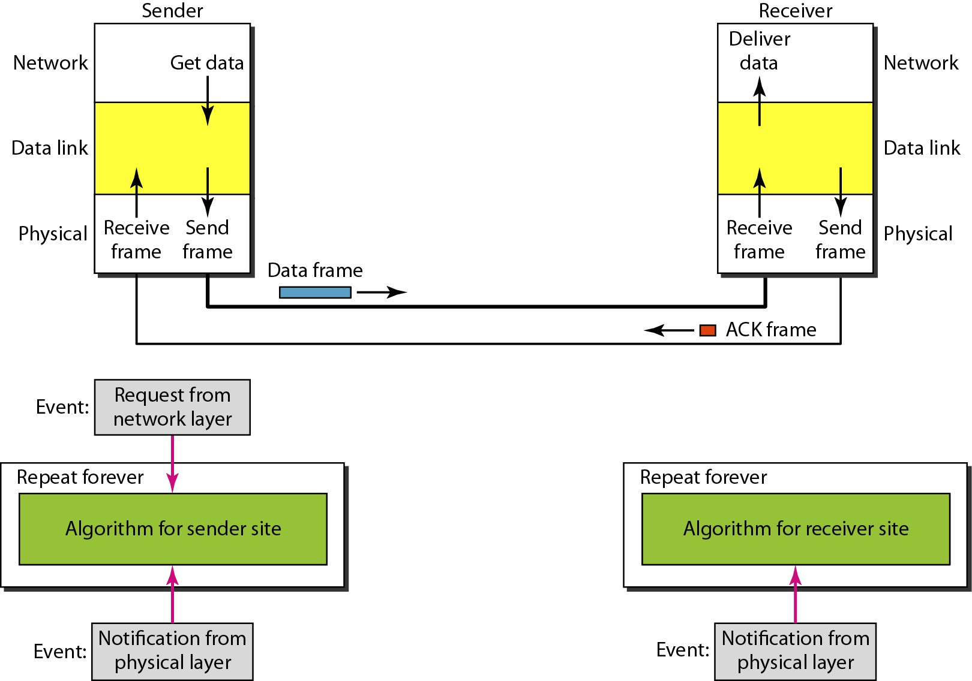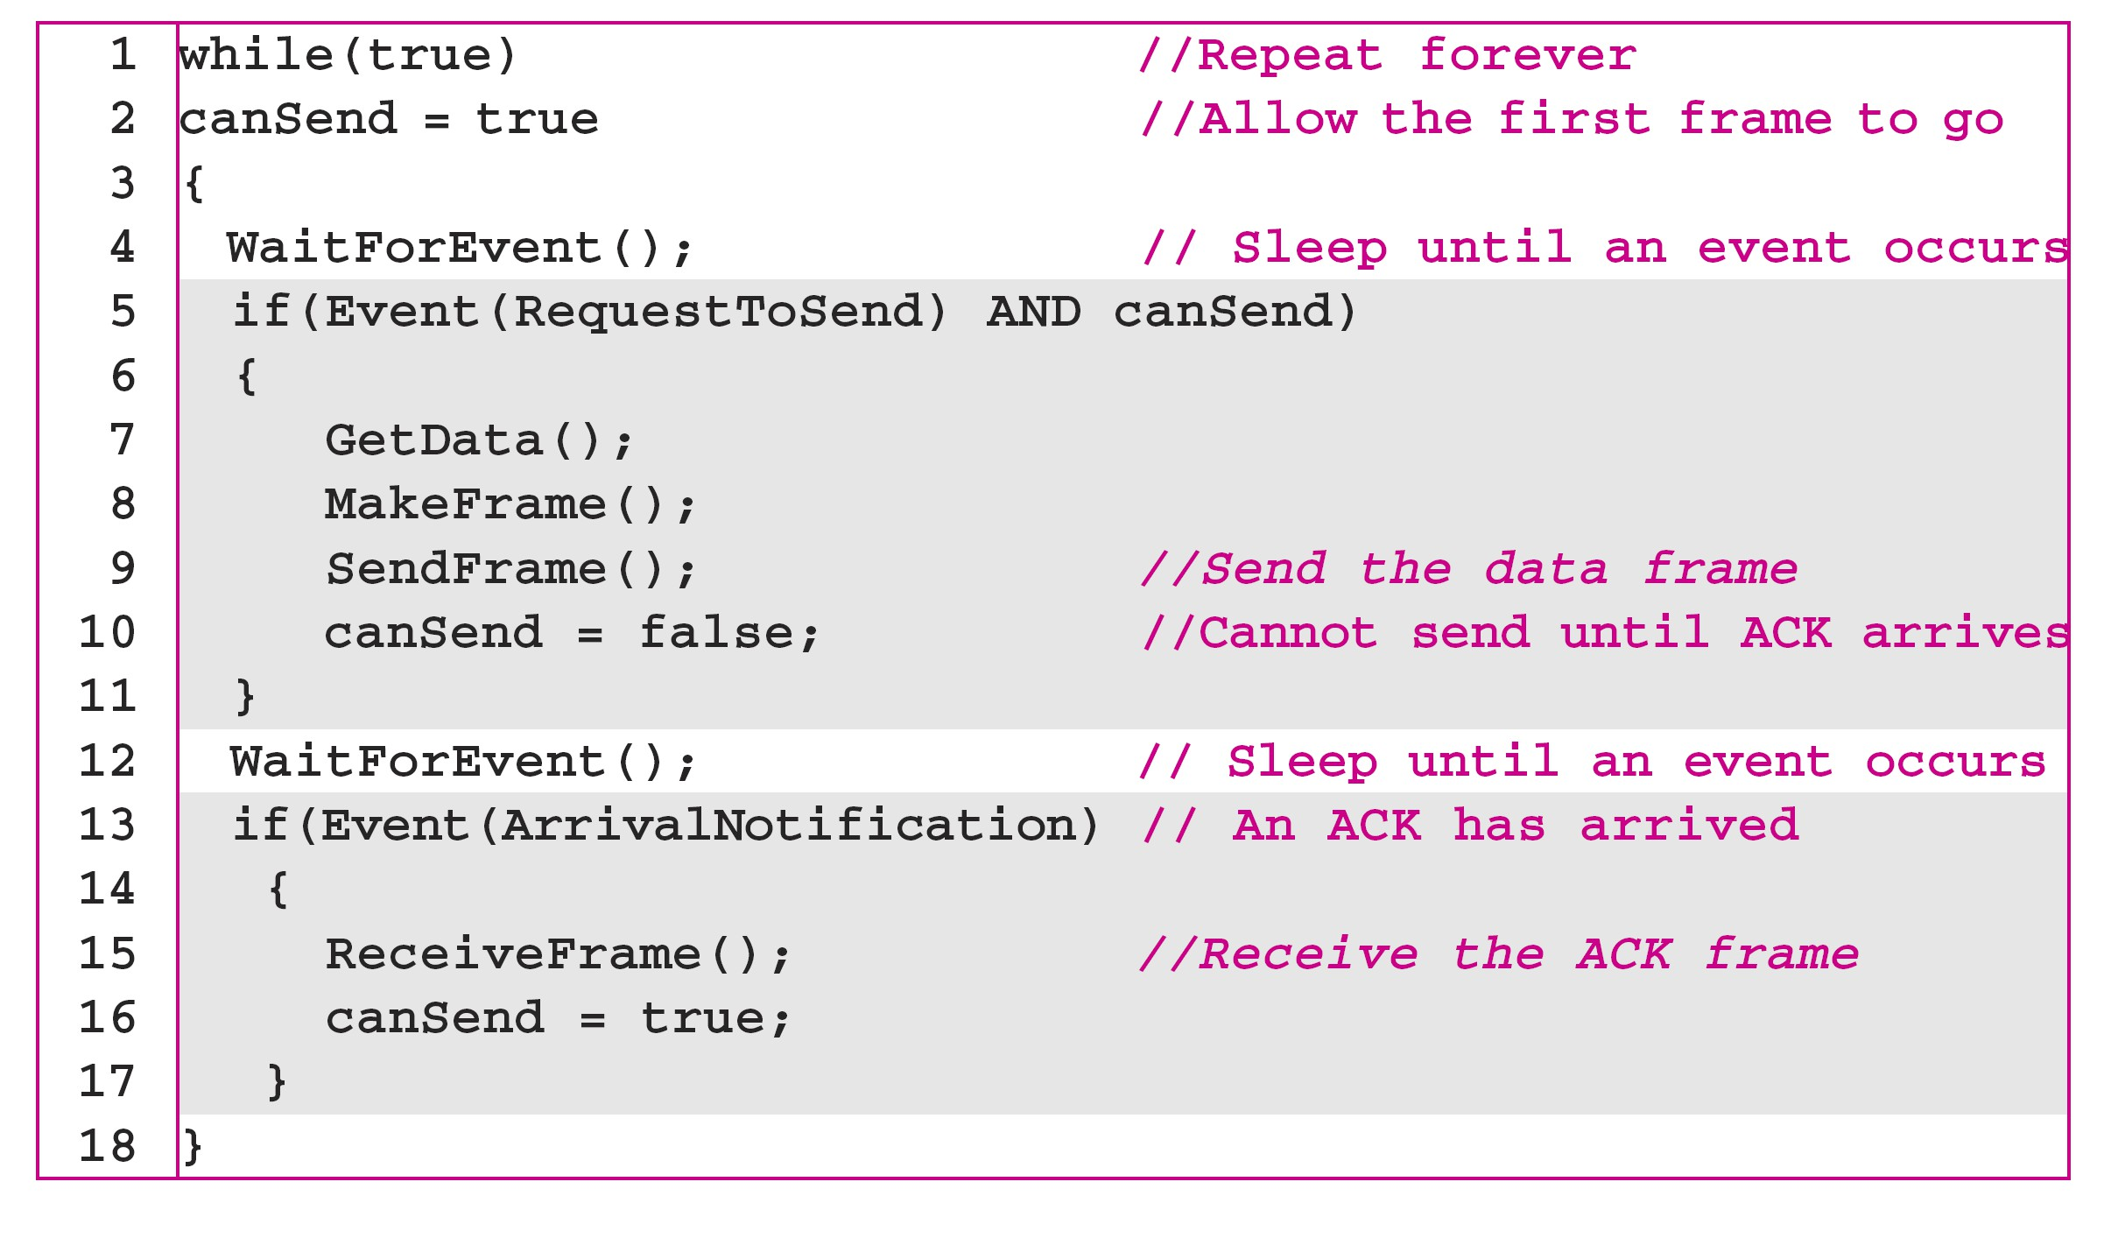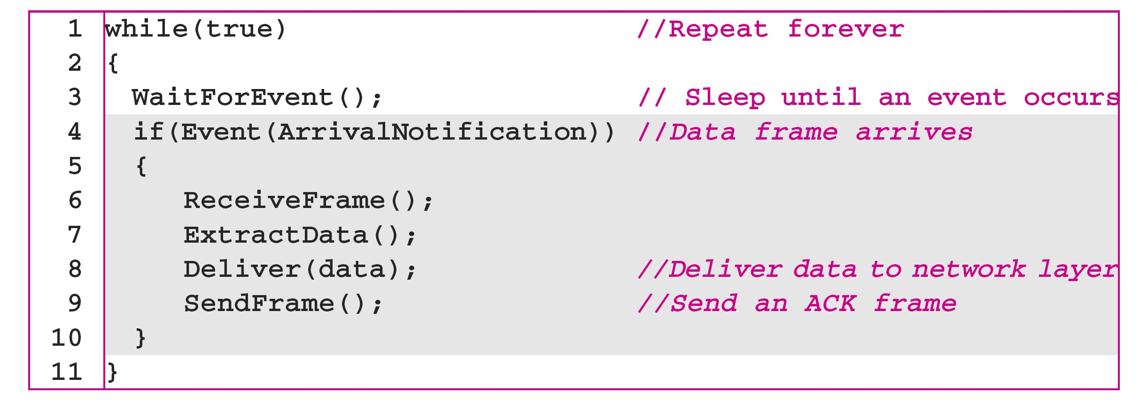

Figure 11.7 *Flow diagram for Example 11.1* Figure 11.8 *Design of Stop-and-Wait Protocol*

11.18 11.19

Algorithm 11.3 *Sender-site algorithm for Stop-and-Wait Protocol* Algorithm 11.4 *Receiver-site algorithm for Stop-and-Wait Protocol*

11.20

11.21

